Practical no. 26
Name :- Danish Altaf Solkar Enrolment no. :-24111590805
Class :- CO3K – B Subject :- OOP
Aim :- Write a program to write and read objects in binary file using write() and read() methods.
Program :-
#include <iostream.h>
#include <fstream.h>
#include <conio.h>
class Student {
int roll;
char name[30];
public:
void getData() {
cout << "Enter Roll No: " << endl;
cin >> roll;
cout << "Enter Name: " << endl;
cin >> name;
}
void showData() {
cout << "Roll No: " << roll << endl;
cout << "Name : " << name << endl;
}
};
void main() {
clrscr();
Student s1, s2;
s1.getData();
ofstream fout("student.dat", ios::binary);
fout.write((char*)&s1, sizeof(s1));
fout.close();
cout << "Object written to file successfully!" << endl;
ifstream fin("student.dat", ios::binary);
fin.read((char*)&s2, sizeof(s2));
fin.close();
cout << "Object read from file:" << endl;
s2.showData();
getch();
}
Output :-
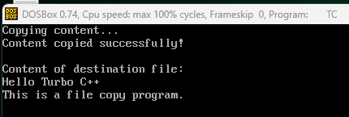

Aim :- Write a program to copy entire content of one binary file at a time using read() and write().
Program :-
#include <iostream.h>
#include <fstream.h>
#include <conio.h>
void main()
{
ifstream fin("source.dat", ios::in | ios::binary);
ofstream fout("target.dat", ios::out | ios::binary);
if (!fin || !fout)
{
cout << "File could not be opened!";
getch();
return;
}
char buffer[1024];
while (fin.read(buffer, sizeof(buffer)))
fout.write(buffer, fin.gcount());
// handle last partial read
fout.write(buffer, fin.gcount());
cout << "Binary file copied successfully!";
getch();
}
Output :-
